**CMS Python libraries Installation Document**

* Install Python 3.7
* In python Console
* pip install r- path
* Path(req_txt)

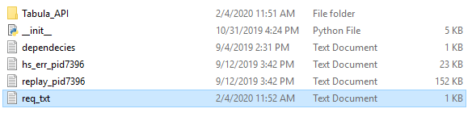

* Change the host(IP address) in __init__.py file



* Run the __init__.py file in python console
  + Change the Directory to __init__.py
  + Command: python __init__py
* In web browser

<http://192.168.0.235:9009/runEngine?fileinput=>path  
 Path of the file

Note: change the host(Ip address) and port number according to init.py file